**Day 36:**

Creating image to run the database

docker run -d -p 9191:8080 akashkale/my-spring-boot: cgi1.0.0

docker ps

<http://localhost:9191>

running mysql image using docker

docker run -d -p 3307:3306 -e MYSQL_ROOT_PASSWORD=root --name=mysql_container mysql:8

docker ps

connect to mysql container os machine

docker exec -it mysql_container bash

it will connect mysql container os

to connect mysql database we need to run the command

mysql -u root -p

password : root

Spring boot MySQL

User defined image pre definedimage

Container container

OS OS

Network

Base OS Window

Docker compose : it is a tool kit which help to run more than one containers. Docker compose take the help of docker-compose.yml file which contains all configuration details to run more than one container and their dependencies.

All container must be running in same machine.

Docker swarm

Kubernetes

Open shift

Etc : these all technologies are help to manage more than one container.

Container management tool (orchestration tools).

docker-compose --version

docker-compose build it build user defined images

docker-compose up --build

docker-compose up –build -d in background

CI and CD tools

Continuous integration and Continuous delivery or deployment

Build : compile, run, test, creating jar or war file.

Dev1 push/pull

Dev2 push/pull Shared Repository 🡨--------🡪 CI/CD 🡨🡪

Pass to other team 🡨🡪 production server

Dev3 push/pull

CI and CD tools

1. Jenkin
2. Bambo
3. GitLab
4. Code pipeline

Jenkin : Jenkin is an open source CI and CD tools base upon Java technologies. Jenkin is plugin base and GUI base CI and CD tools.

Please visit below URL to download Jenkin war file

<https://www.jenkins.io/download/>

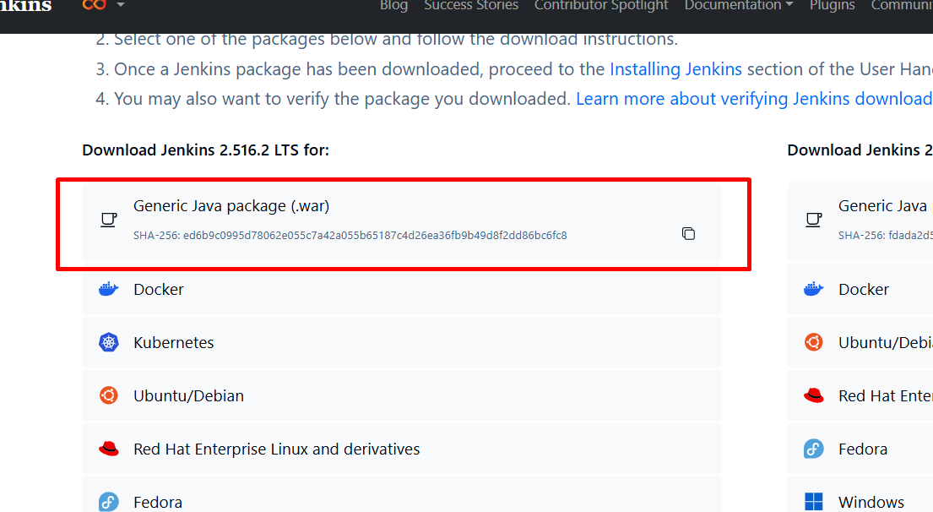

Running the Jenkin server using war file

java -jar jenkins.war (make sure command prompt open in the location war file present).

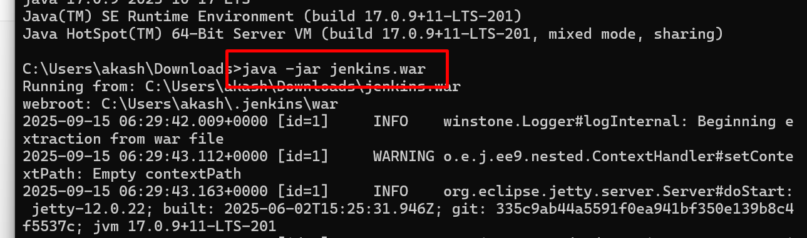

By default Jekin server run on port number 8080

java -jar jenkins.war --httpPort=9091

http://localhost:9091

it will ask you password first time.

password present in console terminal

after provided the password please select the option as install suggested plugin

after this will ask you to create the account.

<http://localhost:9090>

docker-compose down